Test Cases
Initial city_functions.py Run:
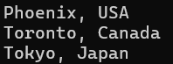

Initial Test:
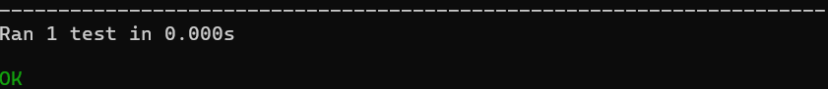

Added Population, Error:
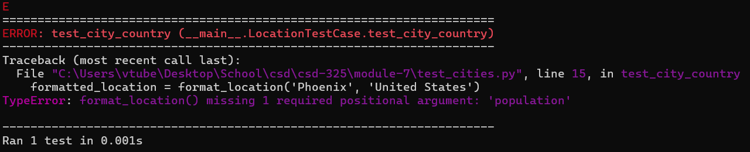

Made Population Optional:
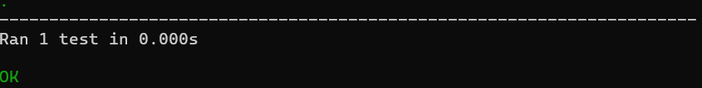

Added Language, Error:
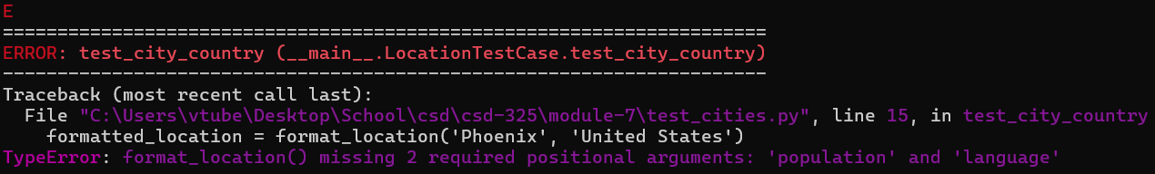
(I also made the population non-optional for this, as was required for the order the parameters were in; if left optional it would have still made an error, just a different one.)

Made Language Optional:
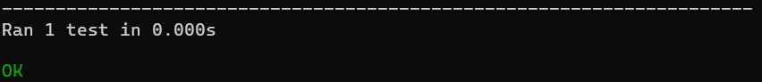

Final cities_functions.py Run:
